Design Document :

**Q1: authentication of users of the API**

User ID and Secret key based Authentication:

When user signup for API service he will be provided user Id and secret keep over an email.

Secret key will be used to sign all request. Service define algorithm for the client to follow when signing the request moreover which part of the message included in Hash Message Authentication code along with the secret key. Once client generated the Hash it will included in request “authorization” header along with user id

Authorization: ijaz:zhdk+ljHzhdklDReh-

When service receives the request it will read the authorization header and spilt the hash and user id. Server will confirm the secret key for user id and generate the same Hash message authentication code. If hash matches the one in the message will guaranty user has right secret key and a valid user.

Authentication will be happen on each request.

Link to tese authentication

URL: <http://localhost:8080/samplerestapis/foursqaue/auth>

**Q2. Sending search queries and searching on a number of directories**

<http://localhost:8080/samplerestapis/googleplus/search/user>

<http://localhost:8080/samplerestapis/facebook/search/user>

**Q3.What would be necessary steps to attach the next online directory?**

To add new directory following class/interfaces will be added

1. Directory endpoint Interface
2. Interfaces implementation
3. Directory connector
4. 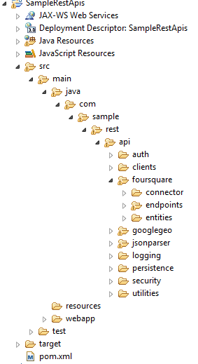Directory Authentication

Common components between all directories:

* Security
* Authentication of own API
* Logging
* Persistence
* Utilities
* Exception/Error handling
* Application properties
* Constants
* Json parser
* Test clients

**Class Diagram (Foursqaure)**

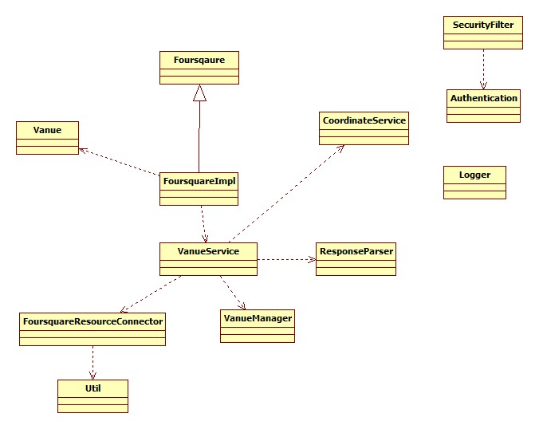

**Test URLS:**

**Foursquare**

http://localhost:8080/SampleRestApis/foursquare/vanue/uberall/ Chausseestraße/berlin

<http://localhost:8080/SampleRestApis/foursquare/vanue/Einstein/Friedrichstr/berlin>

http://localhost:8080/SampleRestApis/foursquare/vanue/K20%20Grabbeplatz/Grabbeplatz 5/dusseldorf

http://localhost:8080/SampleRestApis/foursquare/vanue/DROM/ 85 Avenue A /New York

http://localhost:8080/SampleRestApis/foursquare/vanue/Chelsea Market/ 75 9th Ave/ New York

http://localhost:8080/SampleRestApis/foursquare/vanue/Nando's/ 100 B-2 M. M Alam Rd /Lahore

http://localhost:8080/SampleRestApis/foursquare/vanue/Hyde Park / Serpentine Rd /London

**Locations:**

http://localhost:8080/SampleRestApis/geocode/coordinates/Chester Rd /London

http://localhost:8080/SampleRestApis/geocode/coordinates/ 199 V N Sphere Mal /Mumbai